BIFS 614 – Data Structures and Algorithms
Week 2 Lecture – Algorithms & Algorithm Complexity
ALGORITHMS
The real problem in any bioinformatics programming exercise is defining the algorithm for working with the data structure (and again, don't take this too literally – you'll find that it's very common to go back and forth, redefining the data structure while you are developing an algorithm).
As you learned last week, an algorithm is basically a finite, well-defined set of instructions for accomplishing a task. An algorithm starts at an initial state and ends on a defined end-state. You write algorithms all the time, in your head – some are algorithms for preparing dinner (the initial state is a pile of ingredients, and the end state is a meal), others get you to work (the initial state is you at home with some means of transportation available to you, and the end state is you arriving at work). Computer algorithms have to be very precisely defined (computers will do exactly what you tell them to) - you need to define things like the input values (data structure) as well as every step used to transform that input into the desired output.
Here are just a few common types of code structures you can use when building an algorithm:
- - Linear algorithms are simple series of sequential steps
- - Loop algorithms are sets of steps that repeat until a specific condition is met
- - Nested Loop algorithms are a loop containing another, different loop
- - Branching algorithms consist of a number of sets where different conditions can result in different paths, or processing steps, being taken
Loops are very common elements in programming. Here are some examples, written in pseudocode (recall from last week that pseudocode doesn’t actually run in any language, but rather is written in a way that humans can read and understand):
FOR loop:
for each X of seq [1,3,5,7,9]
Print x
end
This algorithm defines seq as the series of number 1, 3, 5, 7, and 9, and then prints each of them until there is nothing left to print. The condition that terminates the FOR loop is completion of a task for a specific set of values in the data set defined by seq.
There are other ways of defining the number of loops, depending on the language you are writing and executing the code in. For example:
for [a to b]
<statements>
Here you might have the statements include incrementing the value of variable a by 1, so that the loop terminates once that value has reached the value of variable b.
WHILE loop:
While (logical condition) do
<Loop body >
For the WHILE loop, you have to define a condition (for example, X<Y), and the loop will continue to do the code in the “loop body” as long as that condition is met.
Branching code:
An example of branching code is the IF THEN ELSE statement:
if (logical condition)
then
(statements)
else
(other statements)
endif
Here you again define a logical condition, but there are two ways the code can go – if the logical condition is met, the THEN code (which can be one line or thousands) is executed. If the logical condition is not met, the ELSE code is executed. This is also sometimes called a CONDITIONAL statement.
You may have noticed by now that I have been doing a lot of strange indenting in the code snippets above. This indentation is a useful convention many programmers use to help separate where a loop or branch begins and ends – something you'll find very valuable when trying to read through a few hundred lines of code! For some languages, like python, the indent structure is very rigorously controlled and required; for others it’s just for your own ease of use.
Other things you'll need to be familiar with when starting to write code include:
Variable Assignment – basically assigning values to variables so that they can be processed, e.g:
X = 2 (setting a hard value to a variable)
X = B (giving a variable the current value of yet another variable)
Input_sequence = $1 (assigning the first string after the program execution command to a string variable)
Basic Math – doing math with variables, e.g:
x = a + b
x = a/b^2
Again, the exact way you write these various steps is different for each programming language – each language has its own syntax, or grammar, for composing a statement.
Let’s take a look at an example of a piece of code that uses some of these structures. This will be an actual piece of executable code, so you’ll notice that there is a specific syntax and structure used to the code:
Code Example: python 3.5: Counting the # of occurrences of a base in a DNA sequence
You may already have learned some python; don’t worry if you haven’t – we will walk through this simple example together:
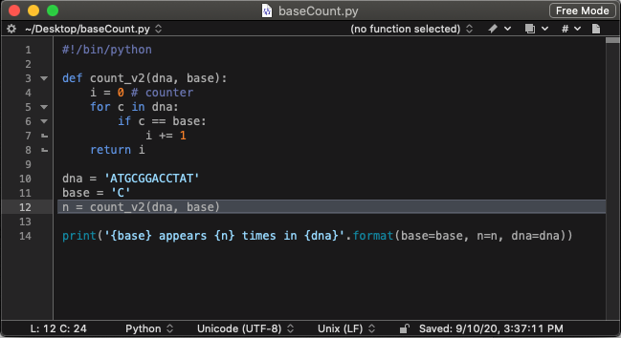
Line 1 begins with a hash symbol (#). This is the comment indicator for python; any lines beginning with the hash symbol are not run. In this case, since the hash is followed by the “!/bin/python”, it tells the interpreter software (and the user) that this is to be run with in python, and that the binary for python is installed at “/bin/python” – which is the default location for any linux-based operating system.
NOTE: this code is written for python 3.5 or higher; I’m using python 3.8 on MacOS. Python 2.5 was deprecated on Jan 1 2020, so you should not use it unless you have to run someone else’s code.
Line 2 is a spacer; I like to leave spaces to separate sections of code.
Lines 3-8 define a function. For this example, the function count_v2 is the only function in the code, and it is in fact the most important bit of the algorithm – the part that counts the number of occurrences of the cysteine residues in the sequence. Note that the function uses variables that are defined later in the code; that’s okay as long as anything that references the function occurs after the function in the code. So if you wanted to move just the variables up higher, above the function, that would work just fine.
So what does our function do? The first line, def count_v2(dna,base): has several components:
def tells python that we are defining a function
count_v2 is the name of the function
dna and base are the required input variables for the function
We end the line with a colon to indicate that the next lines are the actual code for the function.
Line 4 defines a simple counter variable (i) and initializes it by setting it to zero.
Line 5 starts a for loop. The “c” is a variable for the loop; dna is a pre-defined variable that is established in line 10. So what line 5 is doing is saying is that for every base in the variable dna….and then it does the rest of the lines in the for loop. The “c” is where python temporarily stores each base from the variable dna while it is doing the loop – so that the first time through the loop, c is equal to “A”; the next time the loop runs c is equal to “T”, etc. Note the colon at the end of the line!
Line 6 uses a comparator to see if the current value of variable c is equal to the defined value of base we are looking for. Again there is a colon at the end of the line, because there is something to do if the condition is met – and that is done on line 7.
Line 7 increments the counter we set up in line 4. So every time the variable c finds a match in base the counter is incremented – in this case, we are counting how many “C” residues we have encountered.
Line 8 tells the routine that there’s nothing else to and ends the routine, returning the value of “i” (the counter).
Line 9 is just another spacer line.
Line 10 is where the user can enter the value for the variable dna. This is just a short sequence. In practice, it would be smarter to have the program read in a text file so that it would be easy to change the string, rather than editing the code itself.
Line 11 defines the variable base, telling the program which base we are looking for. Again there are smarter ways of doing this – for example, we could just have the algorithm count the frequency of all four bases by putting our function inside a loop that changes the value of base. Alternately if we run this from the command line you can use input flags to tell the algorithm which base to look for.
Line 12 is actually the second most important part of this algorithm (after lines 3-8, the function count_v2). In line 12 we invoke the function, provide the variables, and return the answer back as a new variable, “n”.
Line 13 is another spacer.
Line 14 is where we print out the answer using python’s built-in print command. This outputs the answer to the standard output (the terminal).
We can make our code easier to follow through the addition of more comment lines. Take a look at this updated version of the code – it should be much easier to read what’s going on now that I’ve added several comment lines:
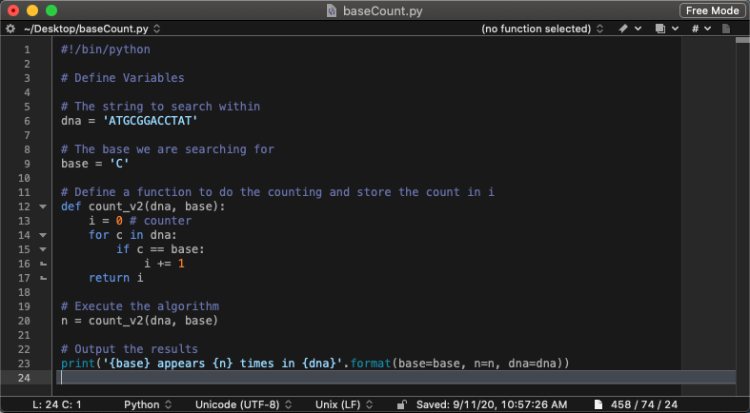
While I was adding comments, I moved the variables to the top to make it easier to modify them.
Python is probably the single most important language used in bioinformatics - – I strongly recommend that you become familiar with it. Here are some good resources – all free to individual users:
Anaconda: allows you to create multiple independent sandboxed python installs
Anaconda Navigator: graphical user interface for working with python and other data science applications
Spyder: A great IDE for building python programs
Bioinformatics Examples in python: http://hplgit.github.io/bioinf-py/doc/pub/html/index.html

Code Example: R:
Now let’s do a simple example in R. As before, you may already have learned some R; don’t worry if you haven’t. We’re going to do things a bit differently here – rather than writing the entire algorithm from scratch, we’re going to take advantage of pre-existing libraries that provide functions. These sorts of libraries exist for python too – it’s a good thing to keep in mind, that you don’t have to reinvent the wheel; chances are someone out there has already written functions or libraries that will do at least part of what you need, so it’s worth time looking at what’s out there before coding.
As before, we’ll walk through this code together:

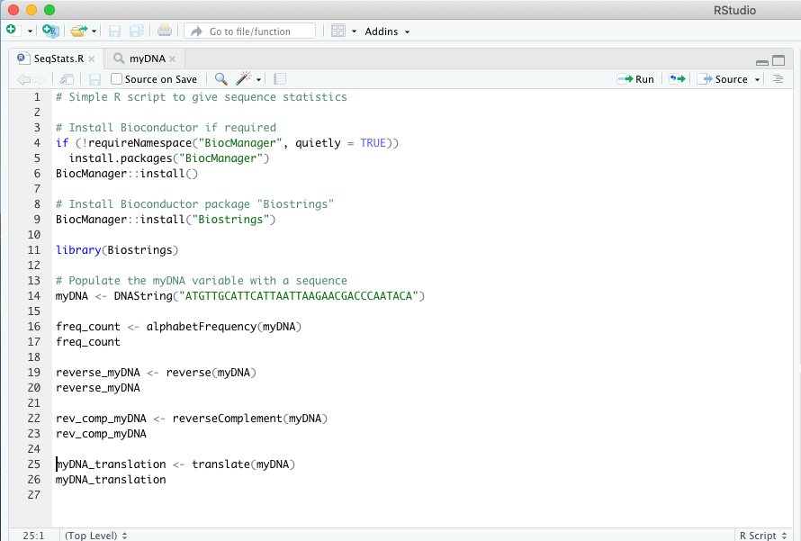
For this example, I’m using the RStudio IDE to help me with my code. It has features like autocomplete and variable exploration that are extremely useful. The window above only shows the code window.
Line 1 is just a comment line where I describe the program. Other useful things you can incorporate here are your name, the date, the version of the software, your contact info, etc – that way if you let other people use your code they’ll know if they have the latest copy, or how to contact you.
Lines 3 is the comment telling us what the next block of lines do.
Lines 4-6 check to see if Bioconductor is required and install it if you haven’t already done so.
NOTE: Bioconductor is a set of extremely useful packages for bioinformatics in R – if you are going to use R for bioinformatics development, you simply have to check out Bioconductor – it will save you an incredible amount of time.
Line 8 is the comment line for line 9.
Line 9 uses Bioconductor’s own package manager to install a package from within Bioconductor called “Biostrings”. This package/library has many nice functions – we’ll take a look at a few.
Line 11 tells R that we need to actually use the “Biostrings” library. You can install many different libraries in your R installation, and you only need to install them once. Whenever you are writing code that needs that library, you simply use the “library” command as in line 11 to load it.
Line 14 uses the Biostrings “DNAString” command to create the variable “myDNA” containing the sequence displayed. You could do this without Biostrings, but the variable type and subsequent processing would be very different than what we are going to do here. Biostrings is saving us a lot of time by creating the variable as a class of variable that it can manipulate intelligently.
Line 16 does all of the frequency counting. Not only does it count all of the “C” residues, as our python program does, but it counts the frequency of every possible type of residue for a DNA sequence!
Line 17 simply tells R to display the variable freq_count. The output is shown in RStudio’s output window, and looks like this:
> freq_count
A C G T M R W S Y K V H D B N - + .
14 7 4 10 0 0 0 0 0 0 0 0 0 0 0 0 0 0
In addition to the 4 nitrogenous bases, this displays the IUPAC code for ambiguous bases. Since there are none in this example, they are all listed as zero.
Line 19 uses yet another function from Biostrings to provide the reverse of the sequence. You can imagine how much easier this is than writing the function yourself! The answer as seen in Line 20 is this:
> reverse_myDNA
35-letter "DNAString" instance
seq: ACATAACCCAGCAAGAATTAATTACTTACGTTGTA
Line 22 reverse-complements the sequence:
> rev_comp_myDNA
35-letter "DNAString" instance
seq: TGTATTGGGTCGTTCTTAATTAATGAATGCAACAT
Line 25 translates the sequence:
> myDNA_translation
11-letter "AAString" instance
seq: MLHSLIKNDPI
We did the same thing in our R example as we did in our python example (count the number of “C” residues in a sequence) – and much more. Using the Bioconductor package “Biostrings” reduced the counting portion of our script to a single line! There are libraries for all sorts of functions that you can install for python to help you in a similar fashion.
R is a common “scripting” language (some people say it’s not programming at all; I tend to disagree). It’s very useful for statistical analysis (and we’ll talk about some of those, like LDA and PCA, later in the course); it has some of the best graph plotting capabilities of any software available. Chances are you may find yourself using it some day – here are some good R resources:
R: The main download and instructions page for R
RStudio: A very helpful IDE (Integrated Development Environment) for R. The desktop (non-pro) version is free, and fully functional!
Bioconductor: A very comprehensive library of functions for bioinformatics in R
R for Biologists: A nice set of tutorials for using R. Includes genomics examples.
Recursive vs Iterative Algorithms
There are two general approaches to repetitive (non-linear) algorithms, iteration and recursion. In general, any given problem is likely to be solvable using either one of these – and in practice you should focus more on solving the problem than on adhering to a specific style of solution. Remember that sometimes the hardest part is to know exactly what the problem is!
RECURSION – a repetitive process in which the algorithm (usually a subroutine or call) calls upon itself. These may have a higher overhead and require more time and memory, but may be a simpler algorithm (which ultimately makes them easier to debug). Recursive algorithms are well suited for recursive data structures – trees and graphs, etc.
Recursive algorithms can be used to simplify a large problem by breaking it into smaller parts and solving them recursively. The general approach is to take a general solution to a “base case” (e.g. something that gives you an answer to a simple problem) and then use that same approach to solve larger problems broken into chunks (the general case).
EXAMPLE: A very simple example would be searching an array for a specific value – the general approach is to take the first value (or element) from the array and test to see if it is the value you are looking for. If it isn't, get the next value and repeat the process (get a value, test it, then repeat) until you either find the value you are looking for, or find that the value isn't present anywhere in the array.
EXAMPLE: Another example is an algorithm to calculate factorials. Recall that a factorial is n!, where n is a number. To calculate the factorial you use:
n x (n-1) x (n-2) x (n-3)... until n is 1 (so that last step is n = 1)
This is essentially a recursive algorithm – many repeating subunits of the same calculation.
Recursive algorithms are used when you have a problem that can be broken into many repeating smaller problems, all of which use exactly the same method to be solved.
ITERATION – an algorithm that repeats until a task is done, usually using loops and counters. Iterative algorithms frequently are more efficient, in that they run faster and use less memory. An iterative algorithm might break the problem into a for-next loop – for example, when solving the factorial above, you would write a loop that does the calculation for “n” steps.
The take home message – writing a program to solve a problem involves knowing which steps you take when you do it yourself, and then writing those steps in a fashion that the
computer can repeat them and get the correct answer. Iterative and Recursive algorithms are two general design ideologies, or approaches, to solving repetitive problems – again, sometimes the best code is the one that gets the answer, not the cleanest or the purest!
ALGORITHM COMPLEXITY
Developers routinely analyze algorithms they've written for two reasons (other than the obvious need to fix bugs):
- - optimization in terms of time of execution
- - optimization in terms of space utilization
First we're going to talk about time of execution, which is affected by several things, including:
- - the hardware running the program
- - the language the program is written in
- - the efficiency of the compiler used
- - the size of the input
- - the organization of the input
We frequently don't have control over the hardware a program will be run on – and you can imagine how annoyed users get when developers tell them “just use a faster machine ”! But we can control the language and the compiler, as well as the structure of the input. Common sense tells us that smaller input files that are arranged in a logical fashion can be processed more readily than large files with a random order of elements. Even when working with big datasets we can break those into smaller, more manageable pieces.
One way to look at running time is to look at the number of times the instructions in the algorithm are executed. Here are 8 lines of pseudocode to illustrate:
1. n = read input from user
2. sum = 0
3. i = 0
4. while i < n
5. number = read input from user 6. sum = sum + number
7. i = i + 1
8. mean = sum / n
If we run this for a test dataset with n datapoints we might see:
Statement Number of times executed
  - 1
  - 1
  - 1
  - N+1
  - N
  - N
  - N
  - 1
A simple example algorithm might be one that looks for the largest number in a series. For example:
Given an array with these values: (1,2,3,4,5)
We could write an algorithm that looks takes the first value in the array and puts it in a temporary variable – called it tempmax, say - then look at the next element in the array and compares it to tempmax. If the next element is larger, replace the value in tempmax with that element and repeat until you've looked at all of the values. In pseudocode:
Tempmax = <first value in array>
for i=2 to n (where n is the number of values in the array)
nextval = (get next value in array)
if tempmax < nextval then tempmax = nextval
This is a very simple algorithm, and not one we could optimize in terms of the organization of the dataset – it simply has to look at all of the values.
Here's another example – a linear search algorithm that searches a dataset looking for a particular element:
i=1
while (i<n and x <>a)
# NOTE: this means the loop runs n times as long as long as x isn't equal to a
i=i+1
if i <> n then location = i
else location =0
In this pseudocode we use the variable location to replace the actual search algorithm – this is just a demonstration, after all, and not runnable code! The test condition basically says that if you haven't found what you're looking for, set the value of the variable location to 0 and keep looking, but once you've found it, set the value of the variable location to i, which corresponds to the position where you found it!
One of the lines in that pseudocode has a pound sign (#) in front of it – that is one of the ways developers can indicate a “comment” – code that isn't there to be executed, but there to remind the developer what that bit of the code is. Using comments is a GREAT practice – it makes it easier to pick up where you left off, or to go back and reuse code bits later.
A linear search algorithm also can't really be sped up – it has to search until it finds what it's looking for. And if we were looking for a specific sequence element (e.g. any ATG in a DNA sequence), we probably would be interested in finding all of the matches, so we still have to process everything.
So instead of a linear search, we could use what is called a binary search algorithm. A binary search algorithm iteratively narrows down the search field until it finds exactly what it is looking for.
Let's take a look at a simple example. Let's say we are looking for the letter “j” in the entire alphabet:
Right now the search “window” is the entire alphabet. But what if we just look at the first half of the alphabet:
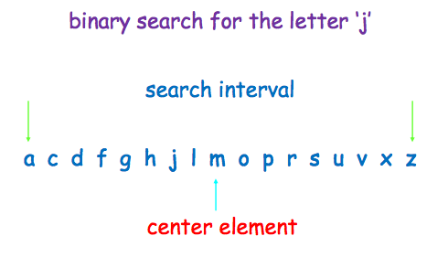
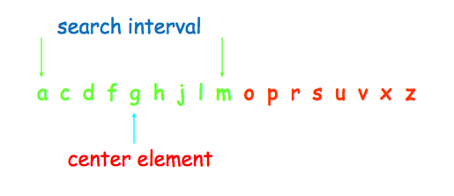
We can iteratively keep making the window smaller, say in halves until we actually find the letter “j”. I'm going to “skip” a few window sizes, you should get the idea:
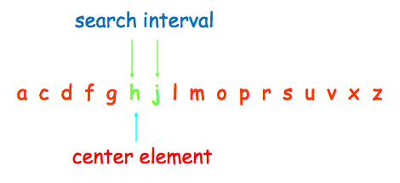
....almost there....
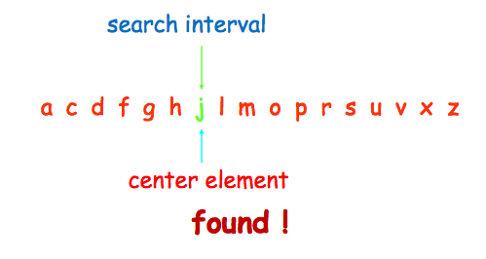
With this approach, we don't actually end up searching the entire array (or sequence) for what we're looking for – we iteratively narrow down the search. Here's how it would work in pseudocode:
procedure binary_search(x: integer; a1, a2, ..., an: integers)
i = 1 {i is left endpoint of search interval – the alphabet in the example above}
j = n {j is right endpoint of search interval}

while (i < j)
begin
m = (i + j)/2
if x > am then i = m + 1
else j = m
end
if x = ai then location = i
else location := 0
What we're really doing here is just chunking the data set and looking for our value in small chunks rather than the whole thing.
AGAIN – this only works if you are looking for one instance of something – if you wanted to search for all instances of ATG in a DNA sequence, you would still, obviously, have to search through the entire sequence!
So the nature of the algorithm matters when it comes to optimization. But another important factor is going to be the size of the dataset. Small inputs aren't really a concern anymore – there just isn't very much complexity when you're searching 10 values. But when you are searching huge datasets of millions of values, the complexity becomes important!
So let's look at data size as it affects optimization. Let's say that Bill and Ted have each written an algorithm to solve the same problem. Using the idea of running time from earlier, if Bill's algorithm has a running time or complexity of 5000n and Ted's algorithm is 1.1n (1.1 to the power of n), for a small dataset (10 values), Bill's algorithm takes 50,000 steps and Ted's takes 3 – clearly Ted's is better, right? But for a dataset of 1000 values, Bill's algorithm takes 5,000,000 steps and Ted's takes 2.5x1041 steps!
So when developing your algorithms, it's important to thing about the nature of the dataset you'll be analyzing and what happens as the complexity changes. This way of thinking about the changes in time and space complexity as the data set increases is a very powerful way to compare algorithms.
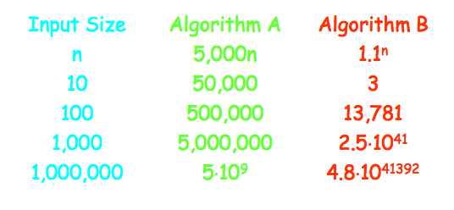
The idea of the growth of complexity of functions (not space) is usually described as “big-O” notation, and it refers to the “worst case scenario” of execution time for a program. Big- O analysis is used to measure the efficiency of an algorithm based on the time it takes for the algorithm to run as a function of the input size – but BigO itself is determined STRICTLY by the terms within the algorithm. Another way to look at it is that Big-O is the complexity value of the algorithm! So when you see someone say “algorithm x is better because it is O(n) and algorithm y is O(2n)” it just means that algorithm y is twice as complex.
We're going to go into some math theory here, but stay with me – the general concept is really the most important thing for you to get out of this right now, but you'll be expected to solve some simple examples of “big-O”.
Let's look at types of complexity first, in order of least complex to most complex:
Constants
A constant value (e.g. “21”) is the simplest order of complexity, requiring no computation.
Logarithmic Complexity or O(logn)
More complex functions like our binary search (also called a bisection search) are logarithmic. A typical bisection search will find its results in 21 or so iterations regardless of the size of the dataset, but each iteration is more complex – so for small datasets it isn't the most efficient way to do the search, but it scales REALLY well.
Linear Complexity or O(n)
Basic addition and subtraction functions will be of a linear complexity, because the number of operations (e.g. if you are adding or subtracting) is directly proprortional to the number of digits. Linear complexity is a low level of complexity and should execute quickly.
Quadratic Complexity or O(n2)
Multiplication and division is more complex because you have more steps in the calculations – this is quadratic level complexity.
Polynomial Complexity or O(nk)
Here the complexity is a polynomial where k can be any constant – this sort of problem is solvable but very complex. Public Key Cryptography is a great example of this type of complexity, computing two prime factors of a large number.
Problems that can be solved with polynomial worst-case complexity are considered tractable, or reasonable. Problems of a higher complexity are considered intractable, or unreasonable, and they may include:
Exponential Complexity or O(Cn)
Factorial Complexity or O(n!)
As an aside - if there's no algorithmic solution to a problem at all, we call it unsolvable.
So what if I have an equation that uses more than one type of mathematical function (e.g. both a linear and a quadratic type of function)? Ignore the simpler one and calculate the Big O using only the most complex type of function, since the lesser complexity stuff will be “trivial” in comparison. There's a chart later on that shows the order of complexity for common mathematical functions.....
Let's look at an example using just math. Our function f(x) that we will test for complexity (the O) will be a quadratic formula.
Say we want to show that f(x) = x2 + 2x + 1 is O(x2) (quadratic complexity) For x>1 we then construct:
x2 + 2x + 1 ≤ x2 + 2x2 + x2
This simplifies algebraically into:
x2 + 2x + 1 ≤ 4x2
For C = 4 and k =1, we have: f(x) ≤ Cx2 whenever x > k So the function f(x) is O(x2)!
It might make more sense if you see it as a table, where some basic mathematical functions are display along with how quickly their algorithmic complexity increases as the dataset of size n grows in size:
